# **Systems test 1 review**

# **By: Brae walker**

# Project manager 4 key steps

* Planning
  + Timeframe, cost and quality triangle
  + Identify all tasks and estimate effort and cost
* Scheduling
  + Microsoft project stuff
  + Create work tasks mapped to a timetable
* Monitoring
  + Guiding, supervising, coordinating the project team’s workload
* Reporting
  + Regular progress reports
  + Evaluate risks

# Estimation

* Size vs accuracy, harder to estimate things the bigger the project becomes
* Schedule vs cost, shorter schedule CAN mean more cost. Sometimes impossible

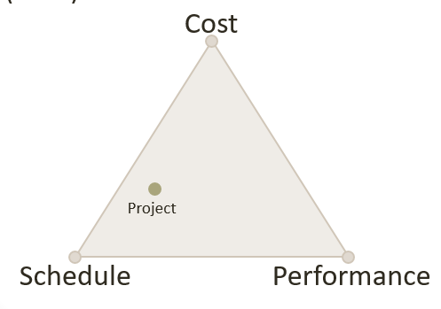

* Things to estimate:
  + Size
  + Effort
  + Schedule
  + Cost
* Estimation techniques
  + Analogy, compare to similar projects
  + Analysis, counting features converting that into size.
    - COCOMO, construction cost model, lines of code to person month estimate
* Estimation activities (benefits of each)
  + Poker planning
    - Each player given cards with different values, shows them when asked about a tasks. Outliers describe why and there is a revote until you reach a consensus.
    - Estimate comes from the team (not manager)
    - A consensus must be achieved
    - Greater numbers have higher uncertainty
  + Table-top planning
    - Stories are placed in groups relative to how they size up next to other stories
    - Stories moved as progress is made
    - Points are assigned to each.
* Estimation is normally done in person-months

# Work breakdown charts

* Gant Charts
  + More information about dependencies
  + More time relative

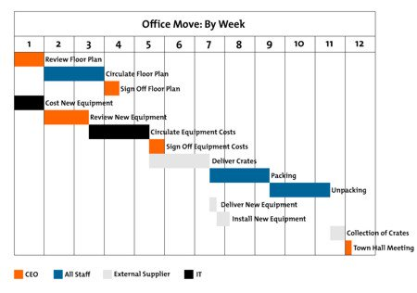

* Pert Charts
  + Used to calculate duration by taking in the optimistic, pessimistic and realistic prediction of time it will take. The average is taken weighting the realistic 4X heavier.
  + Shows dependencies very well
  + Used for critical path

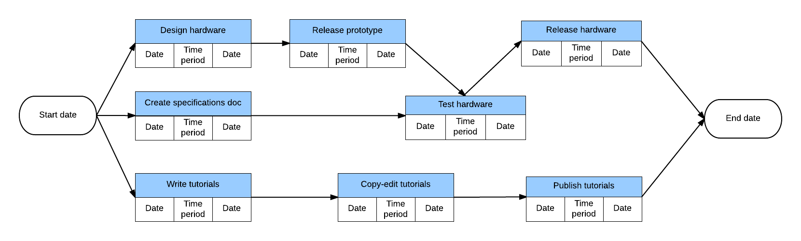

# Velocity

* A team’s velocity is how many points that team can complete in a standard iteration.
* Normally using historical velocity
* Changes with unknown technology
* Changes with new members

# Project Scheduling

* Dependencies
  + Shows when one task can start. Relationship between start and finish of tasks
  + Dependencies: s= start, f = finish. FS,SS, FF, SF
* Gross vs Pure time
  + Pure = working 100% of the time with all focus on that task
  + Gross includes time working on other stuff
  + Be consistent in using on or the other for estimation
* Lead vs lag time, advantages and disadvantages
  + Lead: when one task will wait for another but not for its full completion. More lead can mean more risk.
  + Lag: time needed to wait between dependencies. Too much can increase project time
* Fixed Duration
  + Task duration is same regardless of resources (people and time)
* Predecessor vs successor
  + “The *succ* comes after” - Zac
* Summary vs detail tasks
  + Summary is a grouping of tasks with a logical structure (nouns)
  + Detail task is a task that is not further broken down (present tense verbs)

# Risk management (lecture 5)

* Steps to risk management
  + Develop a risk management plan
    - Define management methods, Define contingency plans, define risk catagories
  + Identify the risks
    - What might add risk
    - Who responds
    - Impact of risks
  + Analyze the risks
    - Estimate probability
    - Understand / quantify risk, (dollars, time …)
  + Create a risk response plan
    - Create plan / directions in anticipation
  + Monitor risks
    - Track through the project
* Team size and location
  + Big team = work divided well, but lots of time managing people and communicating. More change for errors.
  + Optimal team size = 3-7 or 4-8
  + Team location is important. With offshore people it is important to:
    - Have video conferences, Strong onsite management
  + Save money with offsite people = good
  + Scheduling can be hard
  + Hard to understand requirements for offshore people
  + Cultural differences
  + Potential communication / technical issues.

# Time estimate types

* Person Days
  + One person day is one person working for ***one full day*** (actually the *work* or *effort*)
  + Required for calculating cost
* Business Days
  + ***Working*** day – need this to be able to calculate calendar days
* Calendar Days
  + Need this to commit to a ***date***